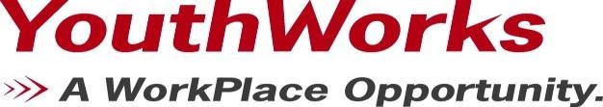

2019 SYELEP RFQ: Career Development, Life Skills & Academic Enrichment Training

Organization Information
Organization Name
Address
Federal EIN #
U.I. #
Contact Person | Name:
 | Title:
 | Telephone #:
 | Fax #:
 | Email:
Program Information
Program Name
Operation Sites
Job Title
Capacity | Area to be Served |  | Participants per Session
 | Bridgeport
 | Stamford
 | Norwalk
 | Valley
Signature of Authorized Representative |  |  |  |  |  | Date
Name and Title of Authorized Representative

